AWS CloudWatch AlertManager

This blog will guide you to get alert from AWS CloudWatch via mail for any of the AWS service like EC2 and get notification for the same service.

I want to implement it to track my AWS EC2 Machine Performance.To be able to reduce cost, you first need to somehow monitor your workload to be able to adjust. If your EC2 instance CPU utilization is beyond threshold then alert manager will inform you that “Your EC2 instance CPU utilization is beyond threshold and needed some action to be performed”.

So let’s start our journey,

Step 1: First of all, you need to have a AWS account. I assume that you have one, if not create one. I highly recommend you to create one from <https://aws.amazon.com/console/>.

Step 2: After creating a account, you will be able to get the AWS dashboard like the below is the snapshot.

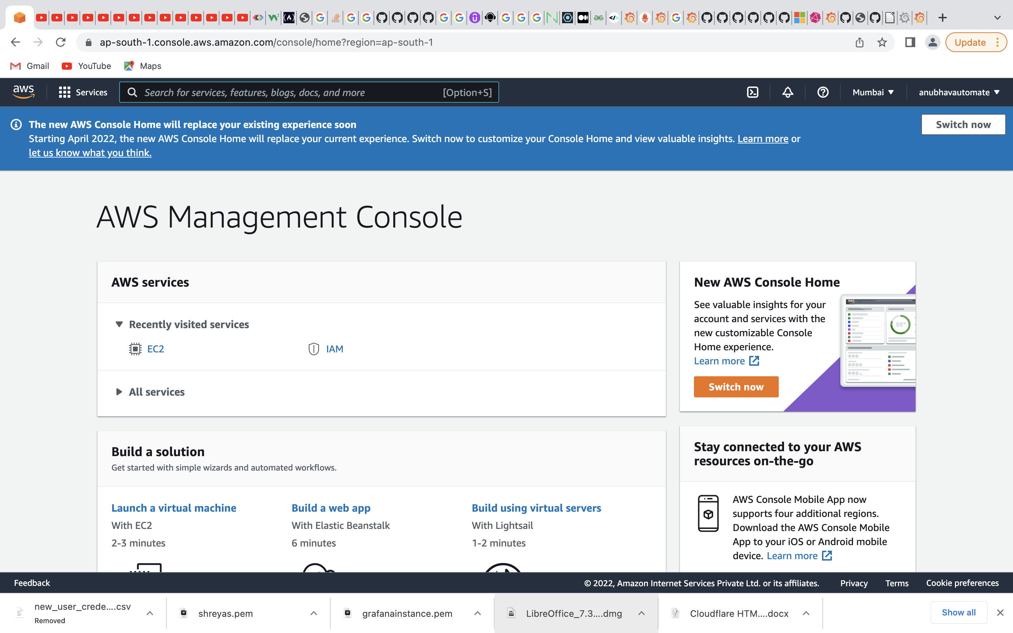

Step 3: Now as soon as you get in Search for EC2 service of AWS at the top search bar and you will get the EC2 Dashboard if you click on it.

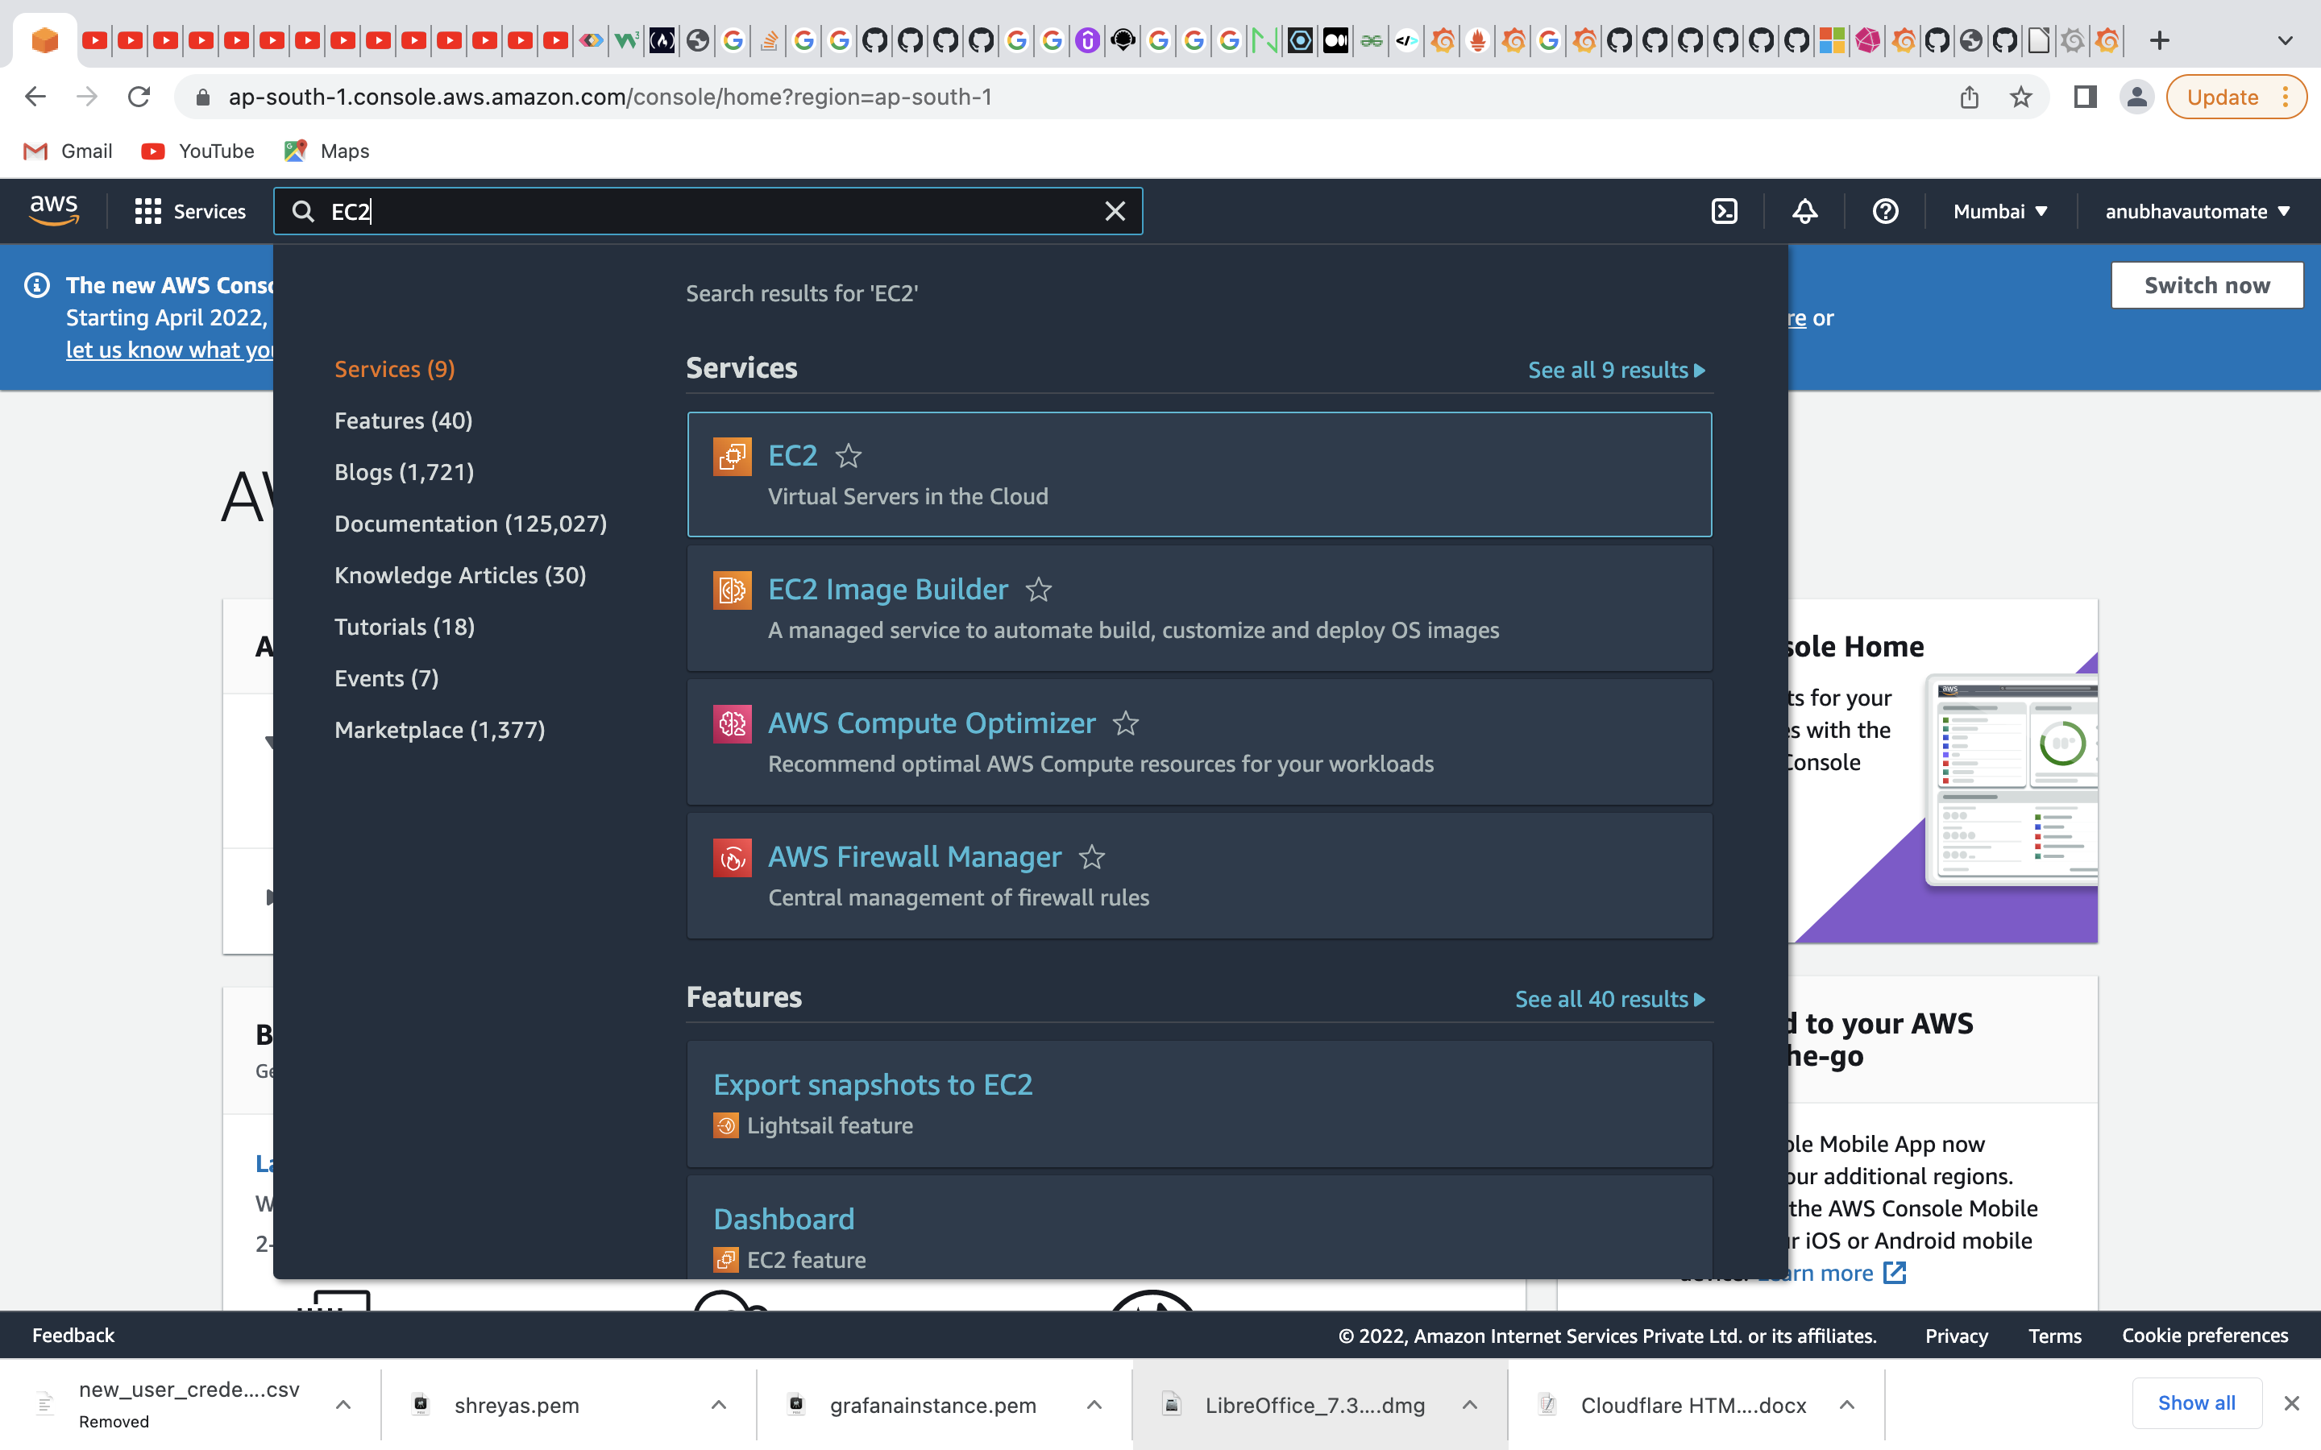

Step 4: In the EC2 dashboard you have none of the instance running at the moment. I have created many instances in the Dashboard. To create an instance you need to follow the below mentioned steps:

Step 1: Choose an Amazon Machine Image (AMI)

Step 2: Choose an Instance Type.

Step 3: Configure Instance Details.

Step 4: Add Storage.(30 gb)

Step 5: Add Tags.(optional)

Step 6: Configure Security Group.

Step 7: Review Instance Launch and Select Key Pair.

Store the key pair file (pem file) in a safe place and then launch instance. You will the get your newly created instance on the EC2 dashboard. Initially, our instance (Demo) is in pending state and when it comes to running state. You can access it. The below is the sample snapshot.

NOTE: Do not share “Pem file” with anyone.

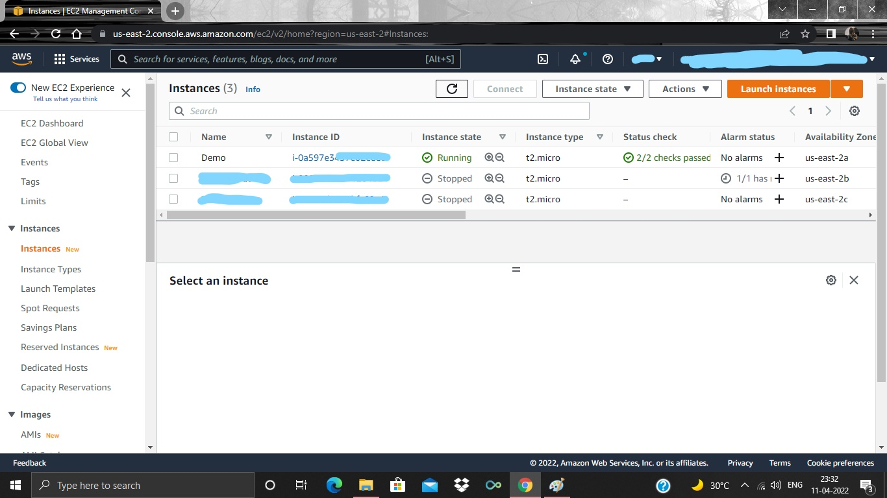

Step 5: Now you need to SSH to the latest instance(Demo) you have created. You can do it by running below command in your terminal from the folder where you have store your “pem file”.

ssh -i “Your pem key” [ubuntu@your_pubilcIPV4address](mailto:ubuntu@your_pubilcIPV4address).

Step 6: Now to check CPU utilization you must have something inside your instance, but don’t worry we have other blog that has grafana installed and we monitor that EC2 instance, if CPU utilization is beyond the specified threshold you will get notification via mail.

LINK: LINK to AWS CloudWatch garafana blog

Step 7: As soon as you get the grafana in the instance you need to go to your instance’s monitoring and on CPU utilization you need to select “View in metric”

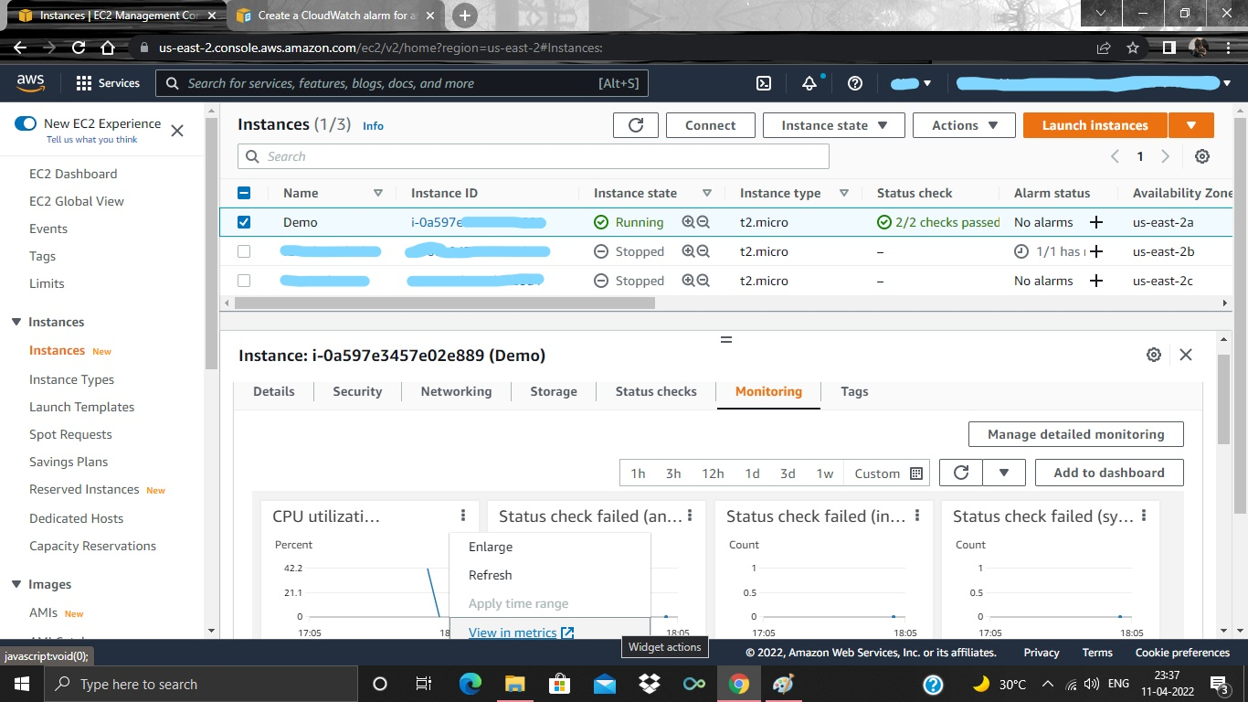

Step 8: There after you will be directed to the CloudWatch’s metric section. Here you need to click on “bell” symbol to set alarm/alert on the selected EC2 instance. The below is the sample snapshot.

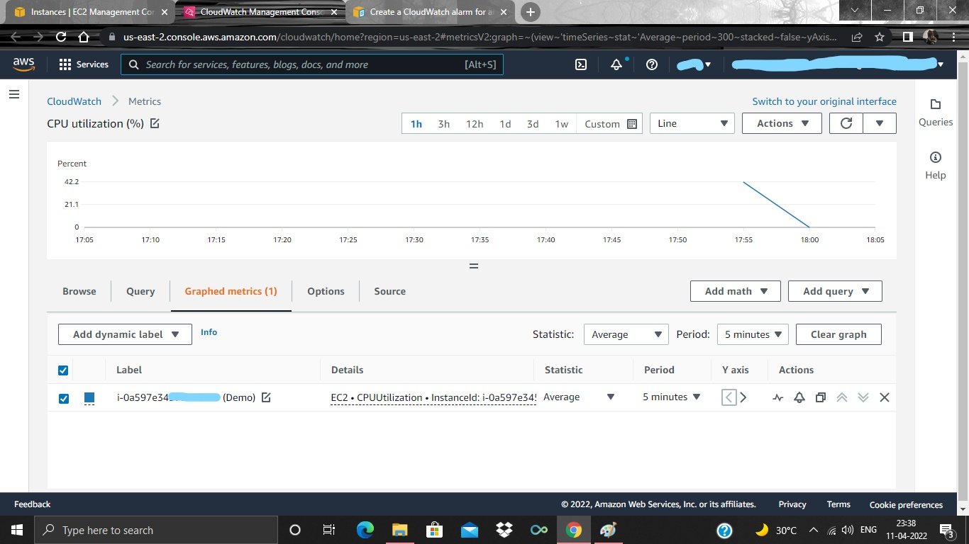

Step 9: Then you will be getting the CloudWatch Alarm section where you need to create alarm. The below is the sample snapshot.

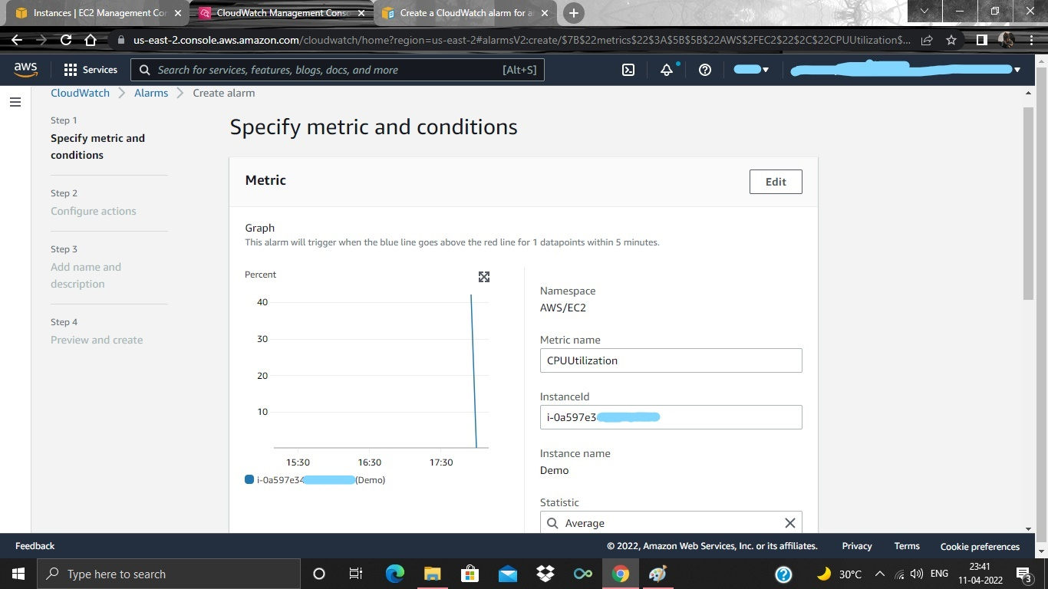  
Step 10: Now, here you need to specify what threshold you want for your instance again it depends on the stuffs you have inside instance. In my case it is showing 40%. So, I keep my threshold “greater and equal” : 40. So if again the CPU utilization of instance reaches to 40 and stays in the 40% for 1 min period then. I will be notified via mail. Below is the sample snapshot.

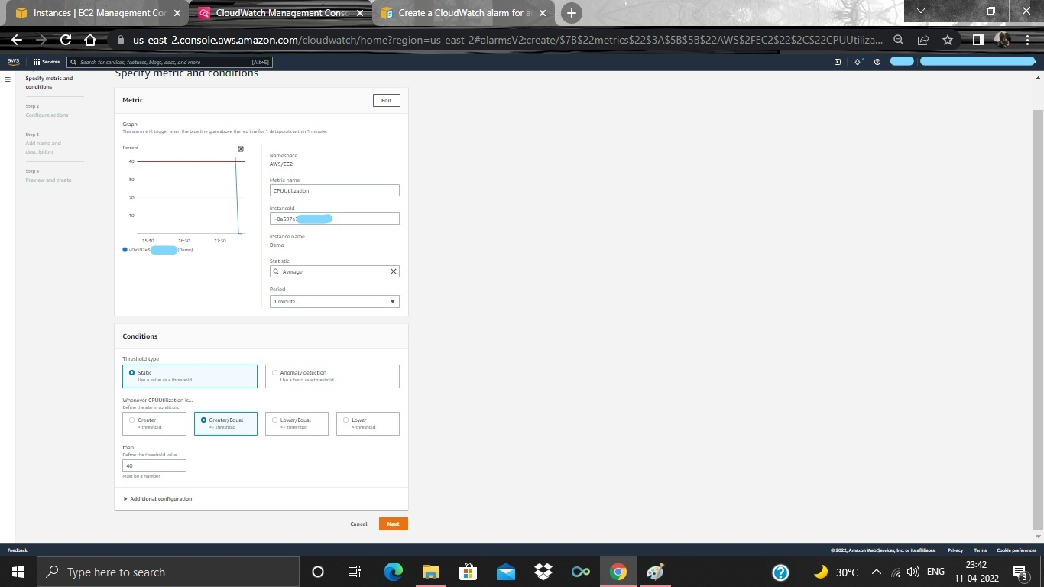  
Step 11: There after, you nee to click on “Next” and configure the notification alert by creating SNS topic (Simple Notification Service), in which you need specify on which mail you want the notification. After specifying you can click “Next”, then you will get the subscription activation mail and from there you need to click on “confirm Subcription”, like below snapshot.

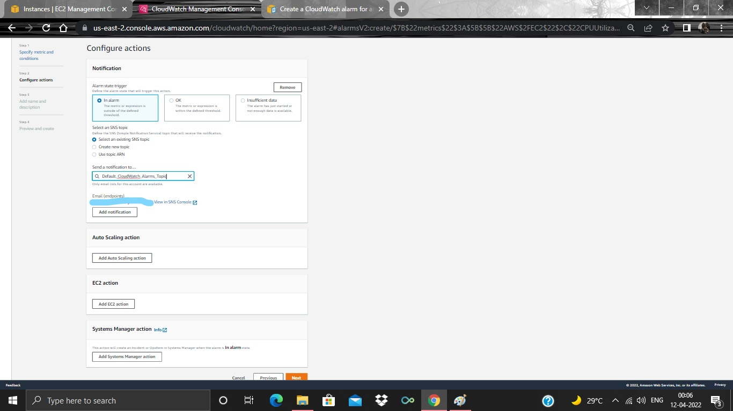  
Step 12: Now you need to give name to the alarm and, click on “Next”, like below sample.

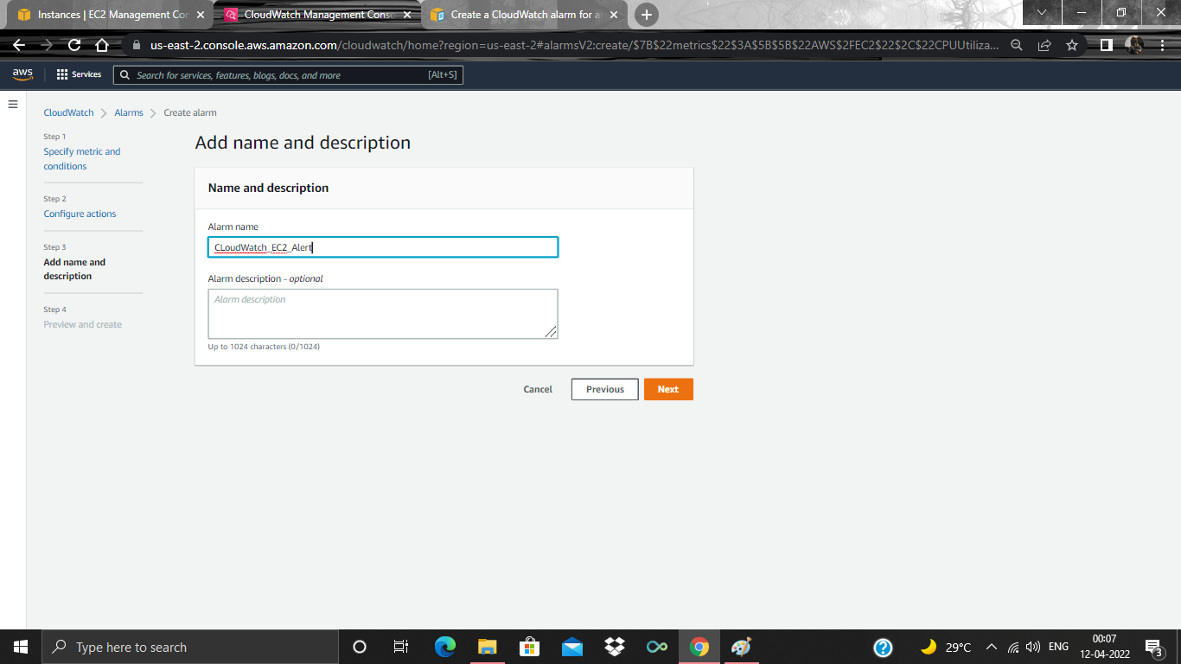  
Step13: Here, you need to review your alarm configuration and click on “create alarm”. Like below sample.

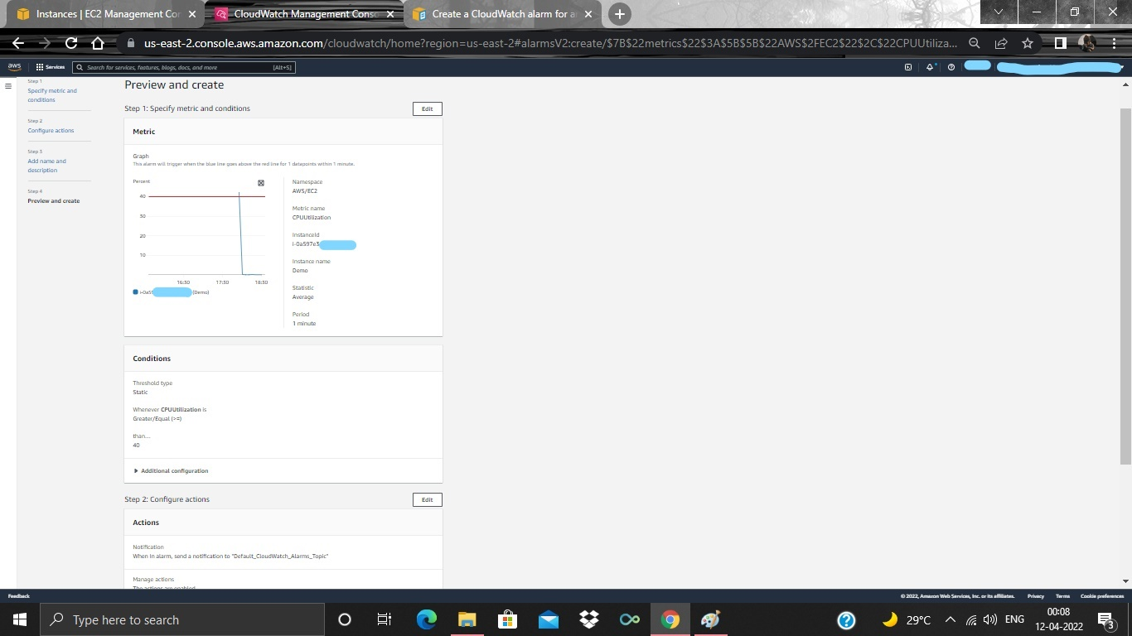  
Step 14: There after, you will be getting your alarm on the CloudWatch dashboard. The below is the sample snapshot.

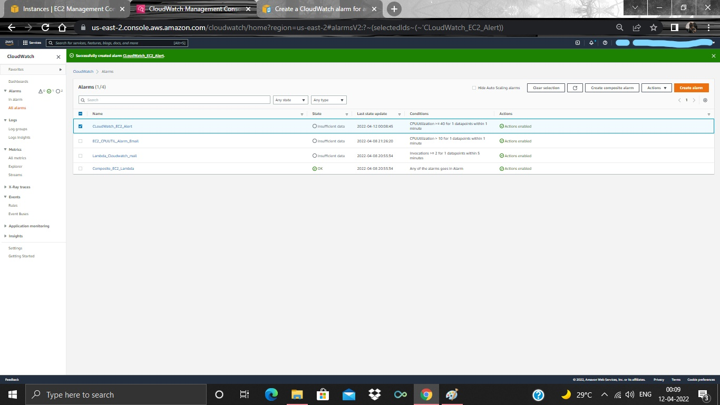  
Step 15: Now, if your instance’s CPU Utilization gets above or equal to 40% you will get notification via mail. Like below sample snapshot.